920W 270 V Connector Servo Motor
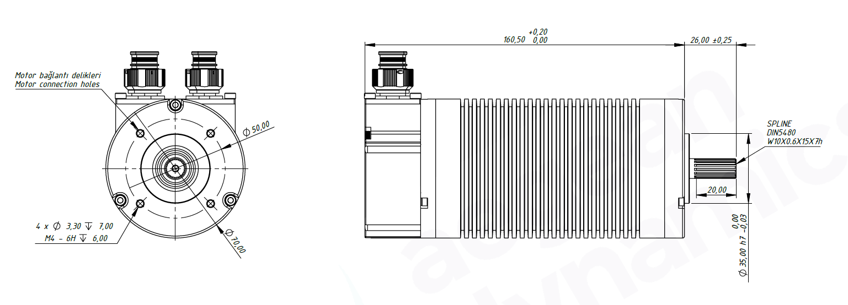
Basic Motor Parameters
Rated Power | W | 920
Rated Speed | rpm | 3600
Rated Torque | Nm | 2.3
Rated Current | A | 4
Rated Voltage | V | 270
No-Load Speed | rpm | 4250
Max. Efficiency | % | 90
Electrical Parameters
Number of Phases |  | 3
Number of Poles |  | 10
Torque Constant (KT) | Nm/A | 0,732
Back EMF Constant (KE) | Vs/rad | 0,732
Terminal Resistance Phase to Phase (±%10) | mΩ | 1650
Terminal Inductance Phase to Phase (±%30) | mH | 2.9
Thermal Data
Ambient Temperature | °C | -40...+85
Max. Winding Temperature | °C | +155
Physical Parameters
Outer Diameter | mm | 70
Shaft Diameter | mm | 10
Max. Lenght | mm | 186.5
Weight | gr | ~2000
Motor Connection
Pin 1 | N/A
Pin 2 | U
Pin 3 | V
Pin 4 | W
Sensor Connection
Pin 1 | GND
Pin 2 | +VDC
Pin 3 | Z’
Pin 4 | Z
Pin 5 | B
Pin 6 | B’
Pin 7 | A’
Pin 8 | A
Pin 9 | U
Pin 10 | V
Pin 11 | W
Pin 12 | NTC
Pin 13 | NTC
Connector Articles
Power | 2M801-009-07NF9-4PB
Signal | 2M801-009-07NF8-13PA

